Epigenetics Final Paper:

Exposure to Violence During Pregnancy, Offspring Cognition, and the Mediating

Effect of miRNA profiles

Jasmine Agostino & Brennan Baker

Environmental Health Sciences

Columbia University School of Public Health

**Exposure to Violence During Pregnancy, Offspring Cognition, and the Mediating Effect of miRNA profiles**

**Agostino, J., MPA, MSW; Baker, B., M.A.**

**Introduction**

Violence is a salient public health concern with far reaching health implications. While violence can impact anyone, Black women from low socioeconomic backgrounds are especially vulnerable to experiencing several forms of violence accumulated over their lifetime.1 Further compounding the issue is violence experienced during pregnancy. Studies purport the prevalence of violence exposure during pregnancy in the general public ranges from 3% to 14%.2 Enduring violence during pregnancy can exasperate health risks and threaten the wellbeing of both the mother and her unborn child.3 Maternal exposure to violence, psychosocial stress, and other severe stressors have been shown to elevate maternal cortisol levels.4

There is no paucity of literature demonstrating the association between prenatal stress and poor fetal development outcomes. In addition to influencing negative birth outcomes such as preterm birth and low birth weight,5 prenatal exposure to violence has been shown to adversely impact offspring neurocognition.6 Children born with neurocognitive impairments have a compromised quality of life including educational problems, poor language development, and reduced ability to self-regulate.7 These problem often persist into adulthood. Possible mediators of this relationship include exposure of the fetus to altered levels of cortisol, cytokines, and serotonin, as well as epigenetic changes.8

***The epigenetic Impacts of maternal and in utero stress***

Human and animal studies have explored the long-term effects of in utero stress exposure through an epigenetic lens. The epigenetic mechanisms related to this relationship may alter microRNA (miRNA) profiles. MiRNAs are highly conserved non-coding RNA that play a role in the regulation of gene expression.9 Studies suggest miRNA expression is associated with stress, although more work is needed.10 Taken together, the role of epigenetic mechanisms in response to maternal violence and evidence of its impact on offspring health has important clinical and public health intervention implications. Accordingly, this study aims to identify the effects of maternal exposure to violence on offspring cognition and examine if this relationship is mediated by child miRNA profiles in cord blood. The authors hypothesize that the mediating role of epigenetics in maternal violence exposure and offspring postnatal health outcomes is illustrated in **Fig. 1**.

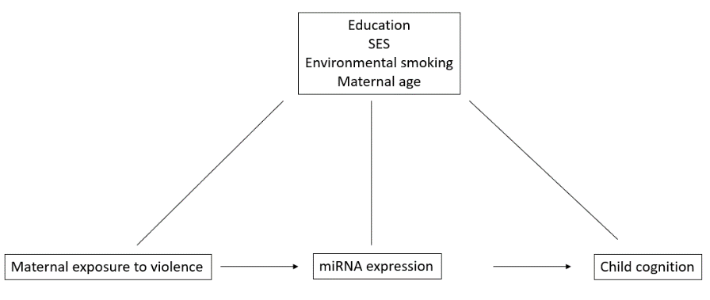

Figure 1

The role of epigenetic mechanisms in mediating miRNA expression in offspring of mothers exposed to violence during pregnancy

**Methods**

**i)Data Collection: Participants**

This study included a sample of 1000 African American, mostly of low socioeconomic status, who were recruited in their third trimester of pregnancy between 2009-2010. We excluded from our analysis participants who were under 18 years old, reported smoking or drinking during pregnancy, and those with pre-existing health conditions.

**ii) Measurements**

Two weeks following participant selection, enrollees completed the MY Exposure to violence (ETV) questionnaire. The MY ETV questionnaire assessed covariate information as well as participants experience hearing gunshots, witnessing and/or experiencing fights, knife attacks, and/or shootings in their neighborhood during their third trimester. Frequency of violent exposure was measured in four tiers, with higher scores indicating exposure extremity: 1 (0-1 exposures), 2 (2-4 exposures), 3 (5-10 exposures), or 4 (>10 exposures). Rasch modeling was applied to summarize item responses. 200uL of cord blood was collected at birth and plasma was frozen at -80C. MiRNA was isolated from the cord blood and analyzed using miRNeasy Kit (Qiagen) and quantified with QuantStudioTM 12 K Flex OpenArray system (Thermofisher).

The McCarthy’s Scales of Children’s Abilities exam was administered by a psychologist to offspring at 48 months old. The exam assessed five cognition outcomes that were aggregated (quantitative, memory, and verbal) to form a General Cognitive Index (GCI) score. Measured cognitive outcomes included memory, motor, quantitative, and verbal skills.

**iii) Data Analysis**

We used linear regression models to examine the following effects: 1) the effect of maternal exposure to violence on child McCarthy General Cognitive Index; 2) the effect of maternal exposure to violence on child miRNA expression; and 3) the effect of child miRNA expression on child McCarthy General Cognitive Index. The models were adjusted for education, SES, maternal age, maternal BMI, environmental tobacco smoke exposure, and child sex. Type I error was controlled using false discovery rate (FDR)-adjusted *p-*values (q values) following the Benjamini & Hochberg method, with an FDR of 5%. Models investigating maternal exposure to violence were done twice: once with the Rasch witness to violence score, and again with the Rasch victim of violence score.

Model 3 identified 3 miRNAs that significantly affected child cognition. To formally assess mediation of the effect of maternal exposure to violence on child cognition by these three miRNAs, we created a fourth model by adding these miRNAs to model 1. Then we compared the beta values for maternal exposure to violence between model 1 and the newly created model 4. If we assume that maternal exposure to violence only affects child cognition through two pathways, a direct one, and an indirect one mediated by miRNA, then we can conceptualize the models as follows: the maternal violence beta from model 1 represents the total effect of maternal exposure to violence (including the direct and indirect effect), while the beta from model 4 represents only the direct effect. Thus, the difference between the maternal violence beta from models 1 and 4 represents the indirect effect of maternal violence mediated through miRNA expression. Accordingly, evidence for mediation would be confirmed if adding the three miRNAs to the model appreciably reduces the beta for maternal exposure to violence.

**Results**

**i) Maternal exposure to violence alters child cognition**

We ran two versions of model 1 using either the Rasch index of maternal witness to violence or the Rasch index of maternal victim of violence scores (Table 1). The degree to which mothers witness violence did not significantly affect child cognition (p = 0.219), while the degree to which mothers were the victim of violence did significantly predict child cognition (p = 0.001). For a ~2.6 decrease in the Rasch maternal victim score, corresponding to less violence experienced by mothers, children had a 1 point increase in McCarthy General Cognitive Index score, corresponding to greater cognitive abilities (Table 1, Figure 2).

|  |  |  |  |  |
| --- | --- | --- | --- | --- |
| Table 1: maternal exposure to violence and GCI score | | | | |
| term | estimate | std. error | statistic | p value |
| maternal victim | -2.583 | 0.801 | -3.223 | 0.001 |
| maternal witness | -0.253 | 0.206 | -1.230 | 0.219 |

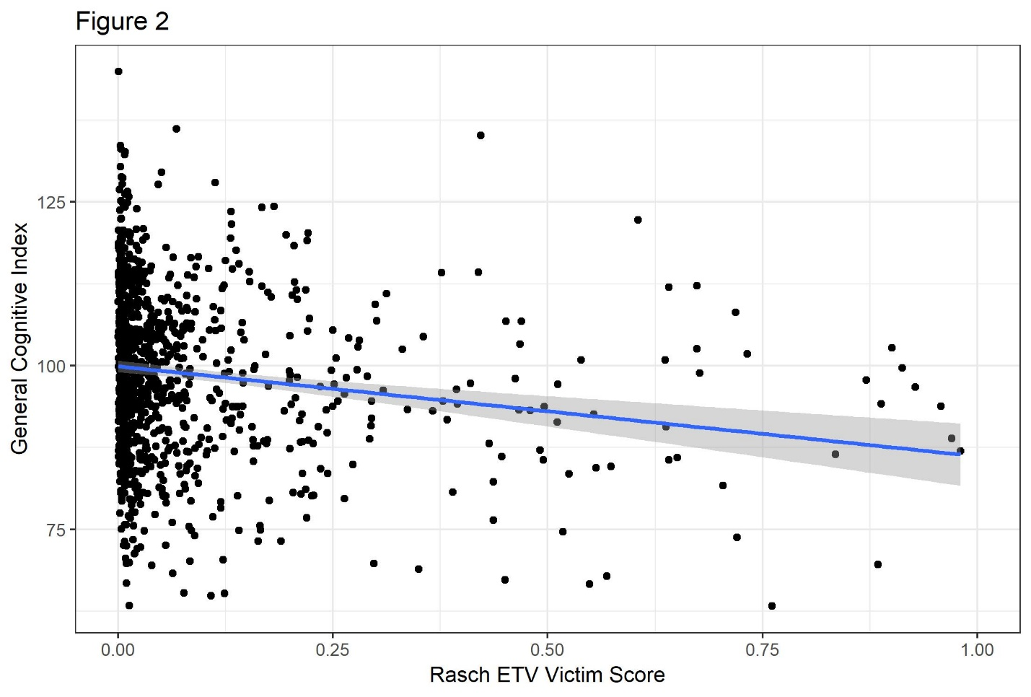

Figure 2

The relationship between Rasch maternal exposure to violence victim score and child general cognitive index. Point for each individual and line for unadjusted linear model shown.

**ii) Maternal exposure to violence alters cord blood miRNA expression**

Using model 2 we found that maternal exposure to violence significantly affected the expression of three miRNAs in cord blood among the 81 miRNAs tested, after adjustment for false discovery rate (Table 2). Among these miRNAs, increased maternal violence upregulated levels of mir_7_B and mir_942_B, but downregulated levels of mir_20a_A.

|  |  |  |  |  |  |  |
| --- | --- | --- | --- | --- | --- | --- |
| Table 2: maternal exposure to violence and miRNA expression | | | | | | |
| miRNA | term | estimate | std. error | statistic | p value | q value |
| mir_20a_A | maternal victim | -0.143 | 0.040 | -3.540 | <0.001 | 0.003 |
| mir_7_B | maternal victim | 0.450 | 0.132 | 3.401 | 0.001 | 0.005 |
| mir_942_B | maternal victim | 0.407 | 0.150 | 2.704 | 0.007 | 0.033 |

**iii) Cord blood miRNA expression alters child cognition**

Using model 3 we found that the expression of 36 miRNAs significantly affected child cognition after adjustment for false discovery rate. In Table 3 we present the 6 miRNAs with the smallest FDR adjusted q values. Expression levels of all significant miRNAs were positively associated with child cognition.

|  |  |  |  |  |  |
| --- | --- | --- | --- | --- | --- |
| Table 3: miRNA expression and GCI score for top 6 miRNA hits | | | | | |
| miRNA | estimate | std. error | statistic | p value | q value |
| mir_331_A | 2.520 | 0.506 | 4.976 | <0.001 | <0.001 |
| mir_34a_A | 16.868 | 3.467 | 4.865 | <0.001 | <0.001 |
| mir_92a_A | 2.240 | 0.525 | 4.266 | <0.001 | <0.001 |
| mir_137_A | 4.069 | 0.977 | 4.165 | <0.001 | <0.001 |
| mir_130b_A | 1.232 | 0.296 | 4.161 | <0.001 | <0.001 |
| mir_154_A | 1.284 | 0.311 | 4.134 | <0.001 | <0.001 |

**iv) miRNAs do not mediate the relationship between maternal exposure to violence and child cognition**

Model 4 was created by adding the three significant miRNAs from Table 2 to model 1. The estimate for the effect of maternal victim of violence on child cognition from model 4 was -2.536 (Table 4), which does not appreciably differ from the estimate from model 1 of -2.583 (Table 1). Therefore, we concluded that these miRNAs do not mediate the relationship between maternal exposure to violence and child cognition.

|  |  |  |  |  |
| --- | --- | --- | --- | --- |
| Table 4: test for mediation | | | | |
| term | estimate | std. error | statistic | p value |
| maternal victim | -2.536 | 0.799 | -3.174 | 0.002 |
| mir_20a_A | 2.785 | 0.682 | 4.082 | <0.001 |
| mir_7_B | 0.213 | 0.562 | 0.379 | 0.705 |
| mir_942_B | 0.630 | 0.482 | 1.308 | 0.191 |

**Discussion**

We conducted an analysis to examine the association between exposure to violence during pregnancy and offspring cognition outcomes, and whether this relationship was modulated by changes in miRNA expression. After covariate adjustment for education, SES, environmental smoking, and maternal age, we found a gradient effect between prenatal exposure to violence and child cognition.

Exploring the hypothesis that miRNAs mediate the effect of maternal violence on child cognition, we found that maternal exposure to violence is associated with three miRNAs, but that these miRNAs play no role in mediation. Additionally, we identified 36 miRNAs associated with child cognition. While there was no statistical mediation, the miRNAs associated with maternal exposure to violence and with child cognition may be relevant in neurological processes. For instance, mir-20a has been shown to regulate the expression of Amyloid precursor protein, which is involved in genetic Alzheimer’s disease,11 and involvement of mir-7 has been demonstrated in processes of autophagy and apoptosis in Parkinson’s Disease.12 The miRNA with the most significant association with child cognition, mir-331-A, is predicted to play a role in nervous system organization during development.13 Ultimately, our study indicates that miRNAs and maternal exposure to violence may independently affect child cognition. Other epigenetic mechanisms like DNA methylation changes and histone modifications may underly the relationship between maternal exposure to violence and child cognition, but more work is needed.14,15

**i) Strengths**

If miRNAs did mediate the relationship between maternal exposure to violence and child cognition, this large prospective cohort study of 1,000 mother child pairs would likely have detected such mediation. The prospective nature of the study establishes temporality between exposure and outcome, and the large sample size increases power to detect a clinically relevant effect. Detecting smaller, less relevant effect sizes may require studies with larger samples or large meta-analyses of existing data.

**ii) Limitations**

Exposure to and severity of violence was based solely on maternal self-reports. The reliability of maternal reports are vulnerable to recall bias. Given this limitation, exposure misclassification is possible. Furthermore, due to social desirability bias, those with high exposure to violence may have underreported it. This misclassification of the exposure was likely non-differential with respect to child cognition. Such non-differential misclassification of the exposure is predicted to bias the estimate towards the null. Thus, the true effect of maternal exposure to violence on child cognition is likely larger than the one we see here. No sensitivity analysis was conducted on questionnaire responses. Additionally, no validation studies were conducted.

Micro RNAs were extracted from cord blood, so we are unable to draw conclusions regarding the effect of violent exposure on miRNA expression during gestation. Research has widely recognized the first trimester as a critical exposure period that is especially sensitive to maternal experiences. Given the importance of earlier gestation periods on offspring health outcomes, additional studies are warranted in this area. Novel methods for measuring child miRNA expression during gestation or a measurement of maternal miRNA expression could be informative in characterizing earlier effects of maternal exposure to violence.

Our study did not stratify by offspring sex. Male vs female offspring may be more susceptible to cognition differences and variances in miRNA gene expression after maternal violence exposure. Future studies should consider the impact of offspring gender.

**Conclusion**

Our study found evidence of increased risk of child cognition impairment following maternal violence exposure during pregnancy, however this effect was not mediated by altered miRNA expression.

References

1. Long L, Ullman SE. The impact of multiple traumatic victimization on disclosure and coping mechanisms for Black women. Feminist Criminology 2013;8:295-319.

2. Gazmararian JA, Lazorick S, Spitz AM, Ballard TJ, Saltzman LE, Marks JS. Prevalence of violence against pregnant women. Jama 1996;275:1915-20.

3. Coker AL, Sanderson M, Dong B. Partner violence during pregnancy and risk of adverse pregnancy outcomes. Paediatric and perinatal epidemiology 2004;18:260-9.

4. Oberlander TF, Weinberg J, Papsdorf M, Grunau R, Misri S, Devlin AM. Prenatal exposure to maternal depression, neonatal methylation of human glucocorticoid receptor gene (NR3C1) and infant cortisol stress responses. Epigenetics 2008;3:97-106.

5. Shah PS, Shah J. Maternal exposure to domestic violence and pregnancy and birth outcomes: a systematic review and meta-analyses. Journal of women's health 2010;19:2017-31.

6. Kinsella MT, Monk C. Impact of maternal stress, depression & anxiety on fetal neurobehavioral development. Clinical obstetrics and gynecology 2009;52:425.

7. Perkins S, Graham-Bermann S. Violence exposure and the development of school-related functioning: Mental health, neurocognition, and learning. Aggression and violent behavior 2012;17:89-98.

8. Glover V. Prenatal stress and its effects on the fetus and the child: possible underlying biological mechanisms. Perinatal programming of neurodevelopment: Springer; 2015:269-83.

9. Huang Y, Shen XJ, Zou Q, Wang SP, Tang SM, Zhang GZ. Biological functions of microRNAs: a review. Journal of physiology and biochemistry 2011;67:129-39.

10. Babenko O, Kovalchuk I, Metz GA. Stress-induced perinatal and transgenerational epigenetic programming of brain development and mental health. Neuroscience & Biobehavioral Reviews 2015;48:70-91.

11. Delay C, Calon F, Mathews P, Hébert SS. Alzheimer-specific variants in the 3'UTR of Amyloid precursor protein affect microRNA function. Molecular neurodegeneration 2011;6:70.

12. Sang Q, Liu X, Wang L, et al. CircSNCA downregulation by pramipexole treatment mediates cell apoptosis and autophagy in Parkinson’s disease by targeting miR-7. Aging (Albany NY) 2018;10:1281.

13. Bourassa MW, Ratan RR. The interplay between microRNAs and histone deacetylases in neurological diseases. Neurochemistry international 2014;77:33-9.

14. Radtke KM, Ruf M, Gunter HM, et al. Transgenerational impact of intimate partner violence on methylation in the promoter of the glucocorticoid receptor. Translational psychiatry 2011;1:e21.

15. Schechter DS, Moser DA, Paoloni-Giacobino A, et al. Methylation of NR3C1 is related to maternal PTSD, parenting stress and maternal medial prefrontal cortical activity in response to child separation among mothers with histories of violence exposure. Frontiers in psychology 2015;6:690.